# Bai 1

# Bai 2

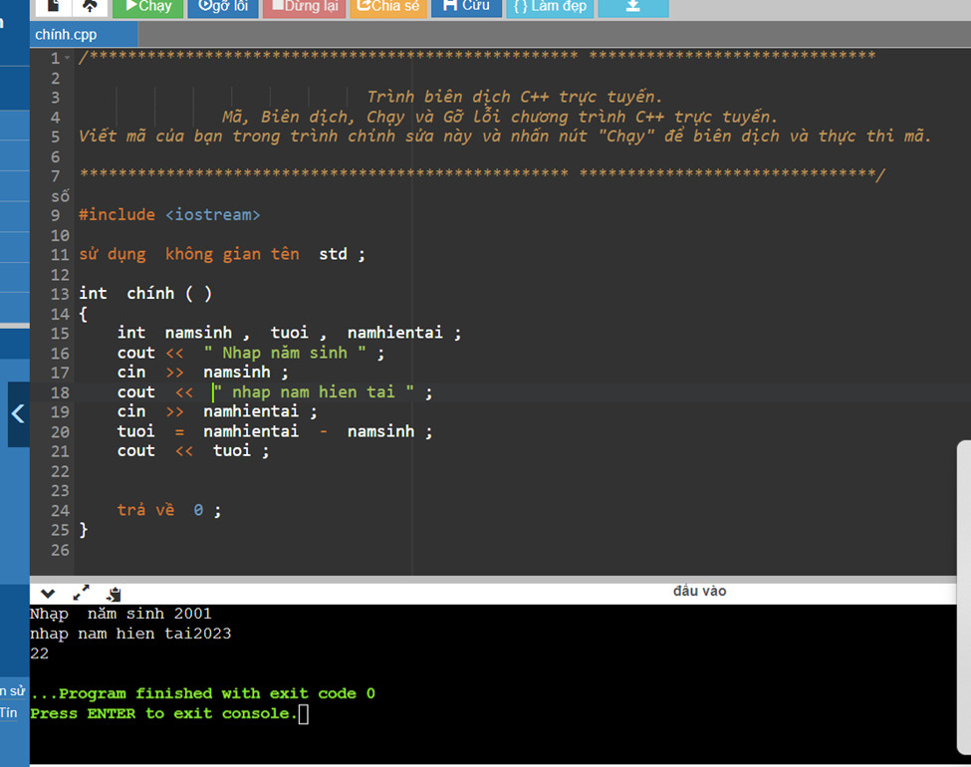

# Bai 3

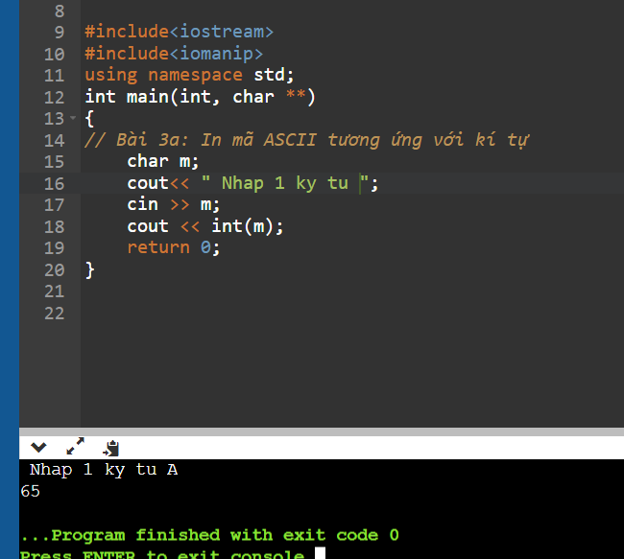

# Bai 4

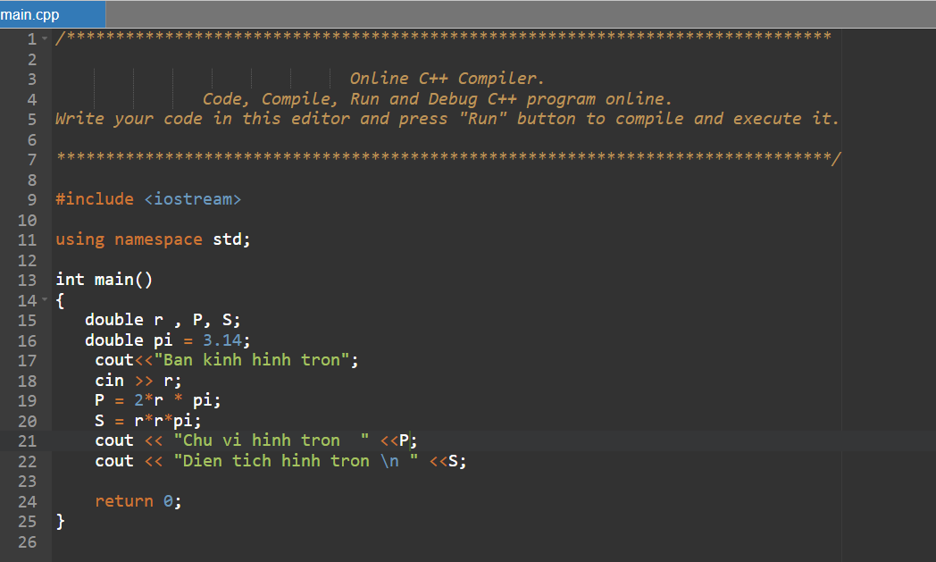

# Bai 5

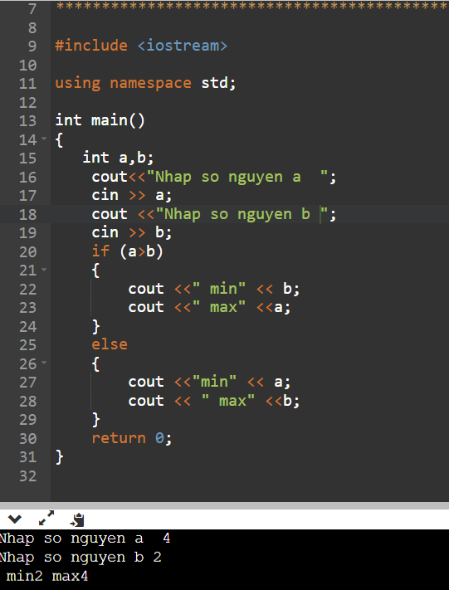

# UNG DUNG

# BAI1

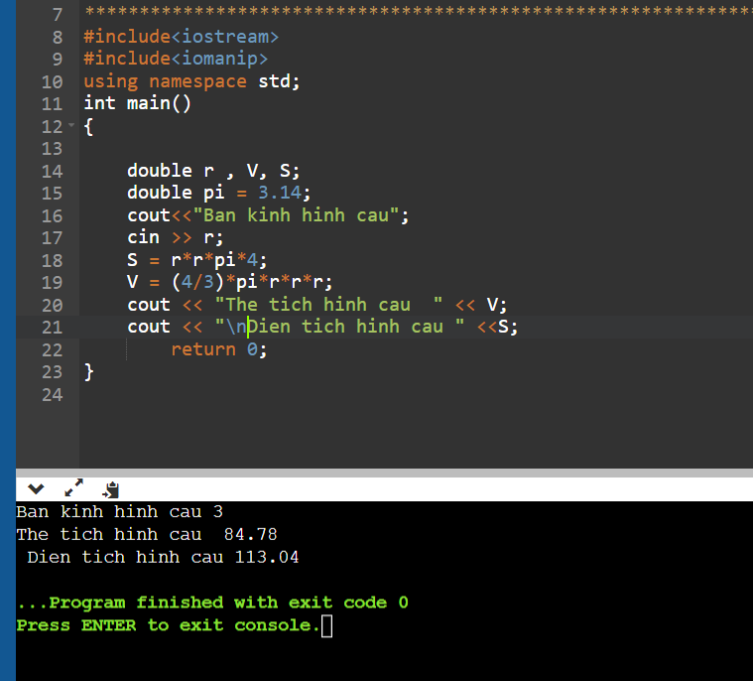

# Baif 3

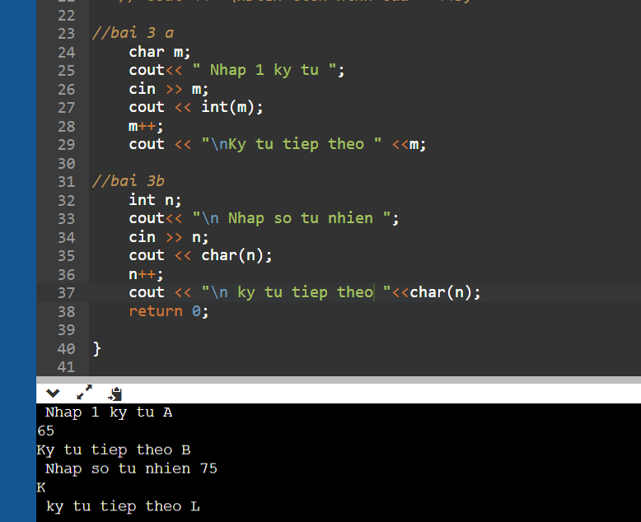

# Bai 4

# Bai 5

